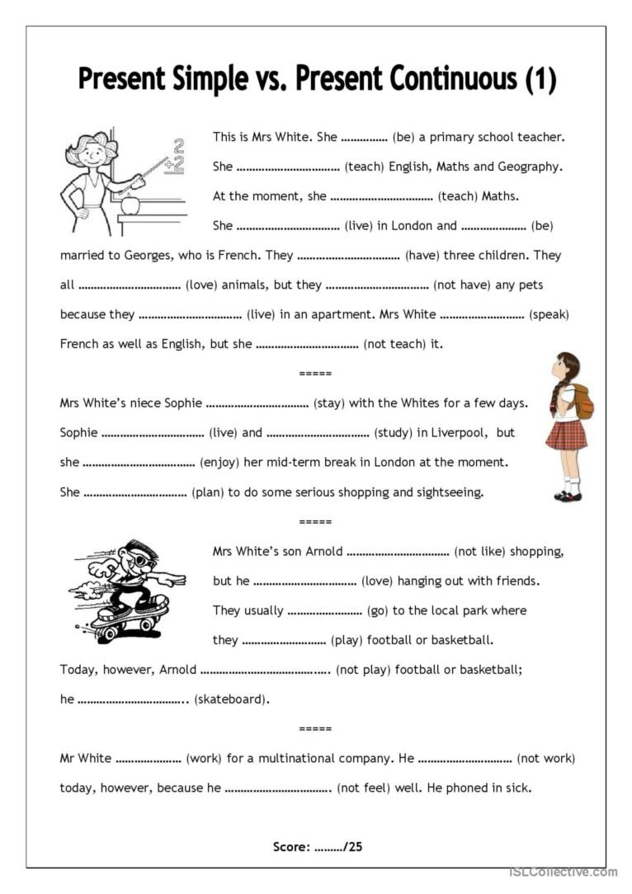

Response – Mauro do Prado Santos:

This is Mrs. White. She is (be) a primary school teacher.

She teaches (teach) English, Maths, and Geography.

At the moment, she is teaching (teach) Maths.

She lives (live) in London and is (be) married to Georges, who is French.

They have (have) three children. They all love (love) animals, but they don’t have (not have) any pets because they live (live) in an apartment.

Mrs. White speaks (speak) French as well as English, but she doesn’t teach (not teach) it.

Mrs. White’s niece Sophie is staying (stay) with the Whites for a few days.

Sophie lives (live) and studies (study) in Liverpool, but she is enjoying (enjoy) her mid-term break in London at the moment.

She is planning (plan) to do some serious shopping and sightseeing.

Mrs. White’s son Arnold doesn’t like (not like) shopping, but he loves (love) hanging out with friends.

They usually go (go) to the local park where they play (play) football or basketball.

Today, however, Arnold is not playing (not play) football or basketball; he is skateboarding (skateboard).

Mr. White works (work) for a multinational company.

He is not working (not work) today, however, because he is not feeling (not feel) well. He phoned in sick.